**Personal Mobile App Project**

**Screenshot 1: App Home Screen**

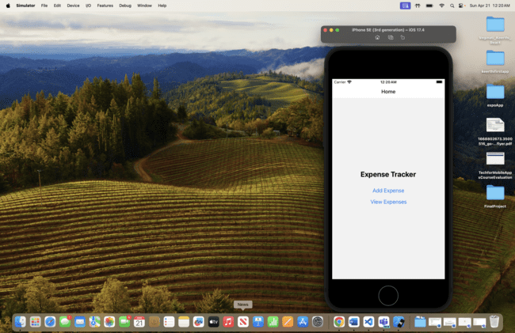

**Screenshot 2: Add Expense Screen**

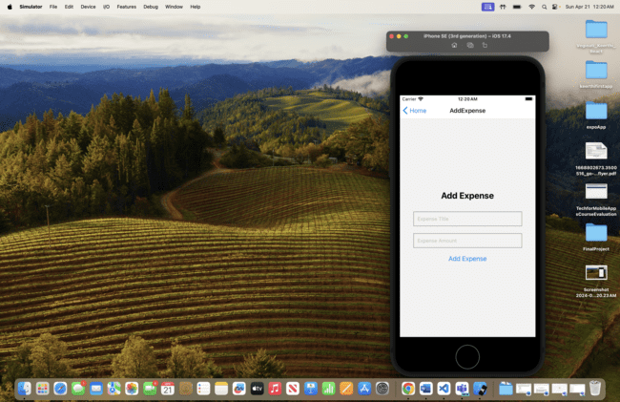

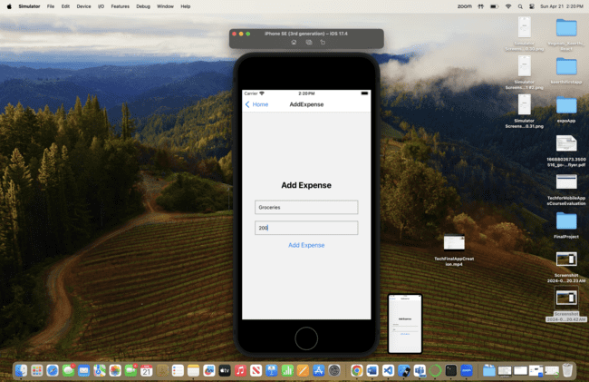

**Screenshot 3: View Expense Screen**

